Asia-China-Coin-Spade-Arched Foot- Yīn jìn -Ding 1992 p. 28v.

晉 Jin Dynasty (1115–1234), Arched Foot Spade, minted by 阴晋, Yīn jìn. The **Jīn Dynasty** ([Jurchen](http://en.wikipedia.org/wiki/Jurchen_language): Anchun Gurun; [Chinese](http://en.wikipedia.org/wiki/Chinese_language): 金朝; [pinyin](http://en.wikipedia.org/wiki/Pinyin): Jīn Cháo; [Wade–Giles](http://en.wikipedia.org/wiki/Wade–Giles): Chin Dynasty, IPA: [[tɕín tʂʰɑ̌ʊ̯]](http://en.wikipedia.org/wiki/Help:IPA_for_Mandarin)); [Manchu](http://en.wikipedia.org/wiki/Manchu_language): Aisin Gurun; [Khitan language](http://en.wikipedia.org/wiki/Khitan_language): Nik, Niku;[[2]](http://en.wikipedia.org/wiki/Jin_Dynasty_(1115–1234)" \l "cite_note-2)[[3]](http://en.wikipedia.org/wiki/Jin_Dynasty_(1115–1234)" \l "cite_note-3) [Mongolian](http://en.wikipedia.org/wiki/Mongolian_language): Altan Ulus; 1115–1234), also known as the **Jurchen (Jurched) Dynasty**, was founded by the [Wanyan](http://en.wikipedia.org/wiki/Wanyan) clan of the [Jurchens](http://en.wikipedia.org/wiki/Jurchens), the ancestors of the [Manchus](http://en.wikipedia.org/wiki/Manchus) who established the [Qing Dynasty](http://en.wikipedia.org/wiki/Qing_Dynasty) some 500 years later. The name is sometimes written as **Jinn** to differentiate it from an earlier [Jìn Dynasty](http://en.wikipedia.org/wiki/Jin_Dynasty_(265–420)) of China whose name is identically [spelled using the Latin alphabet](http://en.wikipedia.org/wiki/Pinyin).

The Jurchen tribes were united by the chieftain and later first Jin emperor, [Wanyan Aguda](http://en.wikipedia.org/wiki/Emperor_Taizu_of_Jin), who overthrew the [Khitan](http://en.wikipedia.org/wiki/Khitan) [Liao Dynasty](http://en.wikipedia.org/wiki/Liao_Dynasty). During the reign of Aguda's successor, the Jin [declared war against the Song Dynasty](http://en.wikipedia.org/wiki/Jurchen_campaigns_against_the_Song_Dynasty) and conquered much of northern China. The Song were forced to flee south of [Yangtze River](http://en.wikipedia.org/wiki/Yangtze_River). The Jin Dynasty fell after their defeat against the rising [Mongol Empire](http://en.wikipedia.org/wiki/Mongol_Empire), a steppe confederation that had formerly been a Jurchen vassal.

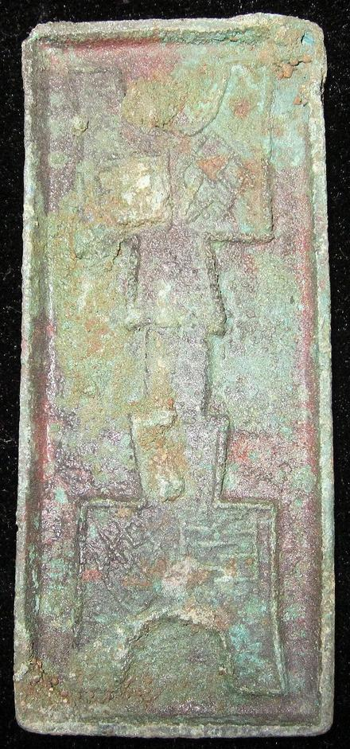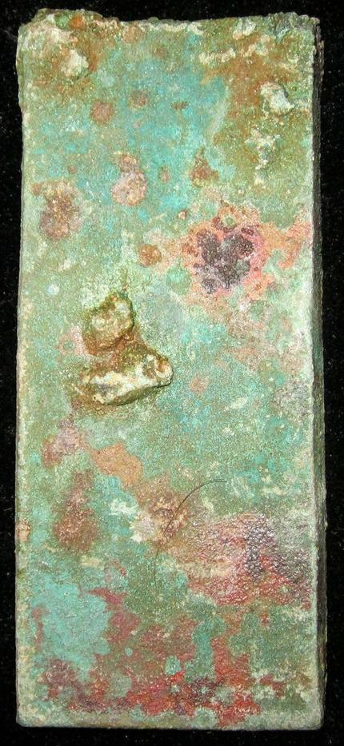

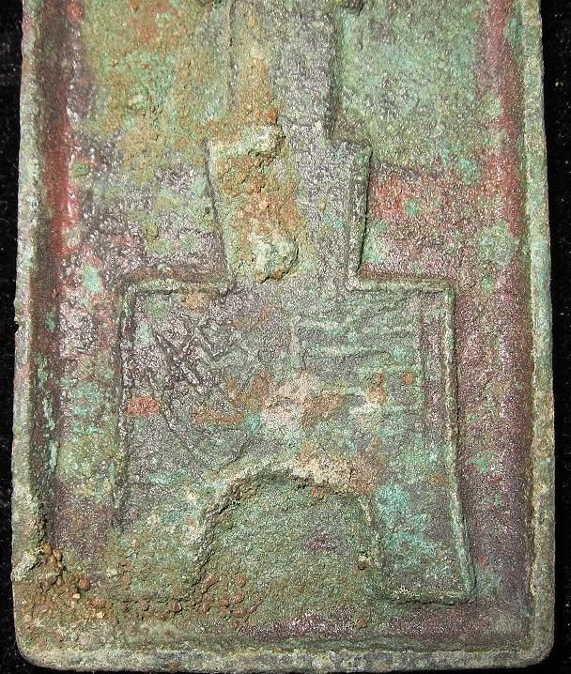

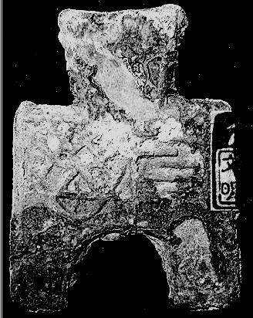

晉 Jin Dynasty Records yin Jin Jian Wen Wei family. In my Yin Jin Qin invasion

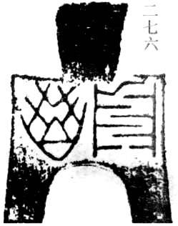

Ding 1992 p. 28v. No price given

史記魏世家Records of the Historian Qian. 文健 Wen Jian. 三十六秦Thirty Six Qin

n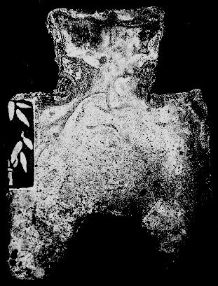 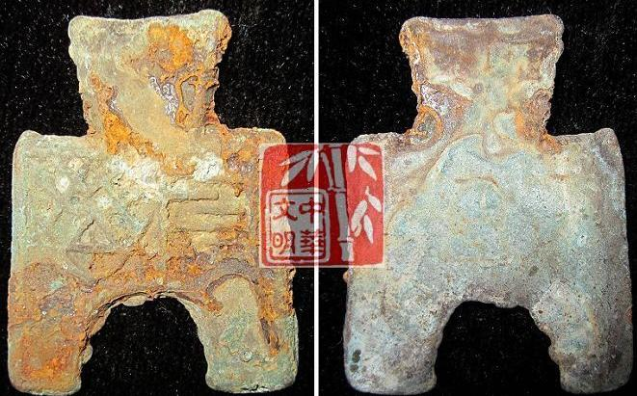

阴晋桥足布 length 3.8CM/1.50Inches, width 2.9CM/1.14Inches

阴晋桥足布."阴晋" which should be a place. It was used in the WEI Nation, middle or late warring sates period.

Order details Printer friendly page

Sold by

[bcculture](http://myworld.ebay.com/bcculture) ( [81](http://feedback.ebay.com/ws/eBayISAPI.dll?ViewFeedback&userid=bcculture)  )

+ Show additional actions

Delivery package 1 of 1

Estimated delivery Thursday, Jan 16, 2014 - Thursday, Feb 13, 2014

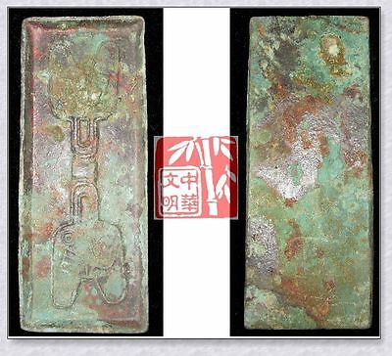

[WARRINGSTATESPERIOD ZHAO NATION MINT MONEY MODEL BRONZE SPADE COIN PATTERN晋阳圆足布](http://www.ebay.com/itm/251391146316)

Item price

$79.99

Quantity

1

Item number

251391146316

Shipping service

Economy Shipping from outside US

[Leave feedback](http://feedback.ebay.com/ws/eBayISAPI.dll?LeaveFeedbackShow&useridfrom=802-867&useridto=bcculture&item=251391146316&transactid=1359873001015) [Contact seller](http://contact.ebay.com/ws/eBayISAPI.dll?FindAnswers&frm=3998&iid=251391146316&redirect=0&requested=bcculture) [Return item](http://return.ebay.com/ws/eBayISAPI.dll?ResolveReturn&eventName=viewSelectedItem&TransactionId=1359873001015&ItemId=251391146316)

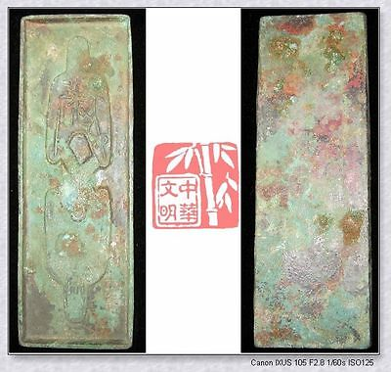

[WARRINGSTATESPERIOD ZHAO CITY MINT MONEY MODEL BRONZE SPADE COIN PATTERN离石三十五圆足布](http://www.ebay.com/itm/251391204570)

Item price

$79.99

Quantity

1

Item number

251391204570

Shipping service

Economy Shipping from outside US

[Leave feedback](http://feedback.ebay.com/ws/eBayISAPI.dll?LeaveFeedbackShow&useridfrom=802-867&useridto=bcculture&item=251391204570&transactid=1359907380015) [Contact seller](http://contact.ebay.com/ws/eBayISAPI.dll?FindAnswers&frm=3998&iid=251391204570&redirect=0&requested=bcculture) [Return item](http://return.ebay.com/ws/eBayISAPI.dll?ResolveReturn&eventName=viewSelectedItem&TransactionId=1359907380015&ItemId=251391204570)

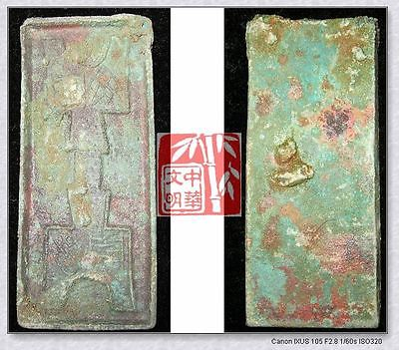

[WarringStatesPeriod WEI CITY MINT MONEY MODEL BRONZE SPADE COIN PATTERN阴晋桥足布RARE](http://www.ebay.com/itm/251412498472)

Item price

$49.99

Quantity

1

Item number

251412498472

Shipping service

Economy Shipping from outside US

[Leave feedback](http://feedback.ebay.com/ws/eBayISAPI.dll?LeaveFeedbackShow&useridfrom=802-867&useridto=bcculture&item=251412498472&transactid=1359874723015) [Contact seller](http://contact.ebay.com/ws/eBayISAPI.dll?FindAnswers&frm=3998&iid=251412498472&redirect=0&requested=bcculture) [Return item](http://return.ebay.com/ws/eBayISAPI.dll?ResolveReturn&eventName=viewSelectedItem&TransactionId=1359874723015&ItemId=251412498472)

### Shipping address

Ralph J Coffman Jr  
149 Atlantic Ave   
Swampscott MA 01907-2427  
United States

Phone number  
781 584 7091

### Order total

Subtotal $209.97

Shipping $95.00

Shipping discount -$6.00

#### Total

## $298.97

[View PayPal transaction](http://payments.ebay.com/ws1/eBayISAPI.dll?IntermediateResolutionInfo&itemid=0&transId=0&pn=UnifiedCheckoutSummaryRedirect2PP&qs=itemid%3D0%26transId%3D0%26buyerorseller%3D0%26)

### Order information

Order placed on  
Saturday, Dec 28, 2013

Having a problem with this purchase?  
[Resolve problem](http://res.ebay.com/ws/eBayISAPI.dll?ResolutionCenter)

Payment method   
PayPal

Payment date  
Saturday, Dec 28, 2013